**Adult English classes at Hopewell Elementary School, Oxford**



Register for free ESL classes to improve your English language skills. Classes are held at Hopewell Elementary School, 602 Garfield Street, Oxford on Monday and Wednesday evenings from 6:30 to 9:00 p.m. You will learn new vocabulary, study grammar, practice conversation and work on reading and writing skills.

To register and take a placement test, please come to the Hopewell Elementary School on Monday, September 12th at 6:30 to Room 119.

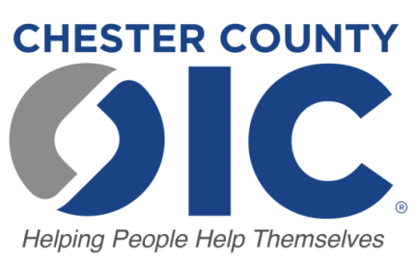

22 N. 5th Avenue  
Coatesville, PA 19320  
610-235-4588  
www.ccoic.org

To register, please contact Maryann Stravous  
 at 610-235-4588   
or mstravous@cc-oic.org